Task 1
Retrieve information about all books stored in the warehouse.
To do this:
- Write an SQL query in the code window.
- Submit it for verification (click the "Submit" button).
- If the query does not work correctly, fix it and resubmit it for verification.
Important! You can use comments in the code window to save different query versions or for explanations. Comments are enclosed between /* and */.
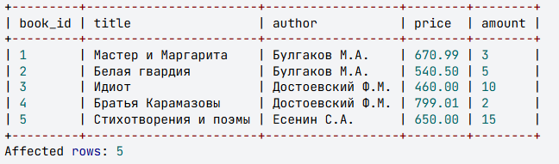

Task2
Select the authors, book titles, and their prices from the book table
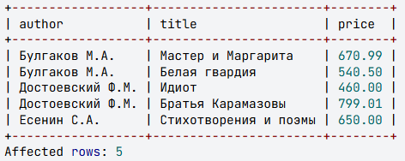

Task3
Select the book titles and authors from the book table, assigning the alias Name to the title field and the alias Creator to the author field.
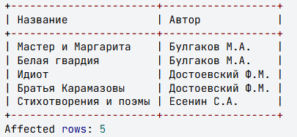

Task4
For packing each book, one sheet of paper is required, costing 1 ruble 65 kopecks. Calculate the packing cost for each book (how much money is needed to pack all copies of the book). In the query, display the book title, its quantity, and the packing cost, naming the last column pack.
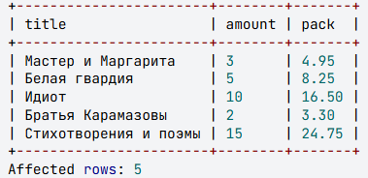

Task5
At the end of the year, the price of each book in the warehouse is recalculated - reduced by 30%. Write an SQL query that selects titles, authors, quantities from the book table and calculates the new book prices. Name the column with the new price new_price, and round the price to 2 decimal places.
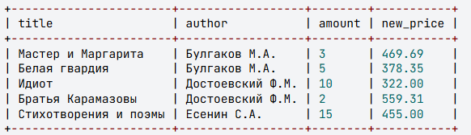

Task6
When analyzing book sales, it was found that books by Mikhail Bulgakov are the most popular, and books by Sergey Esenin are in second place. Based on this, it was decided to increase the price of Bulgakov's books by 10% and the price of Esenin's books by 5%. Write a query that includes the author, book title, and new price, naming the last column new_price. Round the value to two decimal places.
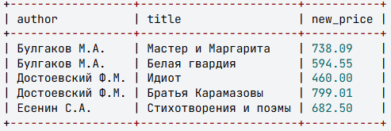

Task7
Display the author, title, and price of those books whose quantity is less than 10.
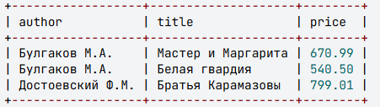
Task8
Display the title, author, price, and quantity of all books whose price is less than 500 or greater than 600, and the total cost of all copies of these books is greater than or equal to 5000.
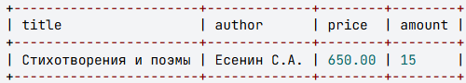

Task9
Display the titles and authors of those books whose prices fall within the range from 540.50 to 800 (including the boundaries), and the quantity is either 2, 3, 5, or 7.
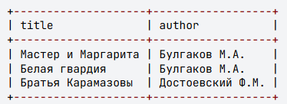

Task10
Select the author and title of books whose quantity falls within the range of 2 to 14 (including the boundaries). Sort the information first by author (in reverse alphabetical order), and then by book title (in alphabetical order).
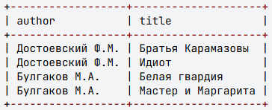

Task11
Select the title and author of books whose title consists of two or more words, and the author's initials contain the letter "С". Assume that in the title, words are separated from each other by spaces and do not contain punctuation marks; there must be a space between the author's last name and initials, and the initials are written without spaces in the format: letter, period, letter, period. Sort the information by book title in alphabetical order.
